**How Amazon API Gateway associate with Lambda Function**

1. **Create a Lambda function for API Gateway**

Create function and update the code

Test it with sample event

1. **Create API Gateway – REST API**

Create new API – Create API

1. **Create a GET Method**

Then associate the lambda-api-gateway - save

1. **Test the GET Method**

Then you get the result

1. **To deploy API as DEV**

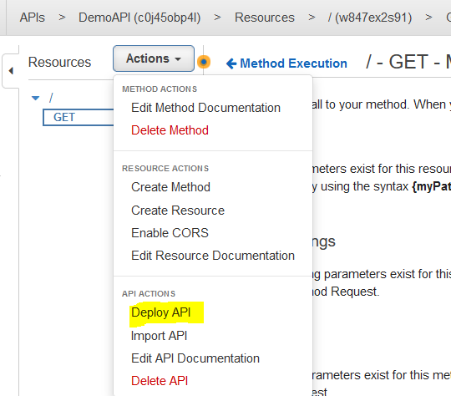

1. **Test the REST API URL**

After deployed API, you will have a Invoke URL.

If you hit the URL, then you can see the Lambda output

